Instructions for Preparing Papers to MSA Engineering Journal
A.B. Author*, C.D. Author †
*Affiliation, Country and Email
Corresponding Author’s Email:

Abstract
This paper proposes itself as just such a template. Using this template as a reference guide, you should be able to understand the form and function of the different parts of writing the paper. The abstract should consist of one paragraph and a concise summary of the material discussed in the article below. It is preferable not to use footnotes in the abstract or the title. The acknowledgement for funding organisations etc. is placed in a separate section at the end of the text.

Keywords: provide a maximum of 6 keywords here in alphabetical order.

- Introduction
MSA Engineering Journal accepts the paper format in LaTeX or MSWord. You can download templates from the journal website. Authors should ensure that the manuscript includes keywords, all figures include relevant captions, all tables include titles, description, footnotes (if applicable). Authors are asked to prepare and submit electronic versions of their full papers according to the instructions below.
- Manuscript preparation
Full papers must be typed in English, and these instructions serve as an example of the required format and font sizes, which are valid for any word processor. The paper's title must be in boldface 18pt and centered, with initial letters capitalized in all words except for articles and prepositions (e.g., in, a, an, and, the, of, from, with, at, etc.). The author’s name should be typed in capital and lower-case letters and centered, followed directly beneath by the author's affiliation, address, and the e-mail address of (at least) the corresponding author, all in capital and lower-case bold letters and centered. Manuscripts must be typed single-spaced using 12-point characters; only Times, Times Roman, Times New Roman, and Symbol fonts are accepted. The text must fall within a frame of 18 cm wide by 24 cm high, centered on an A4 page (21 cm x 29.7 cm). Paragraphs are separated by 6 points of vertical space and must have no indentation. The text of the full papers must be written in a single column and must be justified. The maximum length of the main body of the full paper (excluding the Title Page, Abstract, Keywords, References, Appendices, and Figures/Tables) is 8,000 words. The final format will be a PDF file; authors are required to send a PDF file of their final paper after receiving the galley proof, and all PDF files should NOT be locked (secured), with all fonts and graphics embedded.
- Figures
Figures should be centred, numbered consecutively throughout the text, and each should have a caption underneath it (see for example Figure 1). The figure caption should be written in 10-point. All figures should be included in the electronic versions of the full paper.

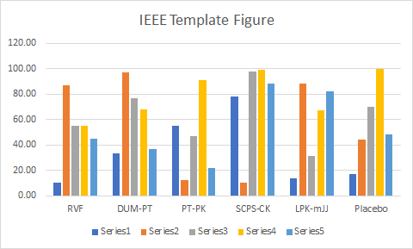

Fig. 1: This is an example of a figure caption.
- Tables
Tables should be centred, numbered consecutively throughout the text, and each should have a title before it (see for example Table 1). The title should be written in 10-point. All tables should be included in the electronic versions of the full paper.

Table 1: This is an example of a table title.
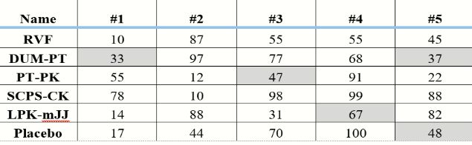
- Equations
Equations should be typed within the text using the equation editor, centred, and should be numbered consecutively throughout the text. They should be referred to in the text as Equation (n). Their numbers should be typed in parentheses, flush right, as in the following example.

$PA + A’P - PBR-1B’P + Q = 0.$ (1)
- Generating a PDF file
The PDF format will be the final format under which the papers will appear in the issue. Therefore, you are required to submit your paper as a PDF document.
- Copyright
Upon acceptance of an article, authors will be asked to submit a 'Journal Publishing Agreement form to the submission system.
- Competing Interests Statement
Upon submission, authors are required to provide a clear statement regarding any potential competing interests that could be construed as influencing the work. This statement must be submitted via the designated field in the submission system, even if the authors have no competing interests to declare. If no conflicts exist, authors must explicitly state: "The authors declare that they have no known competing financial interests or personal relationships that could have appeared to influence the work reported in this paper.”

- Declaration of Interest
All authors must disclose any financial and personal relationships with other people or organizations that could inappropriately influence (bias) their work. Examples of potential competing interests include, but are not limited to, employment, consultancies, stock ownership, honoraria, paid expert testimony, patent applications/registrations, and grants or other funding. Authors must complete the Declaration of Interest section during the submission process to ensure transparency.
- Conclusions
A PDF version of your final paper is required. Our online submission system guides you stepwise through the process of entering your article details and uploading your files.

Acknowledgement
The acknowledgement for funding organisations etc. should be placed in a separate section at the end of the text. Thank you for your cooperation in complying with these instructions.

References
[1] A. B. Author, C. D. Author. “Title of the article”, The Journal, volume, pp. 110-120, (2000).

The list of references should be ordered in the same order as first cited in the text. All references should be cited in the text and using square brackets such as [1] and [2,3]. We recommend the use of IEEE Transactions style for references.

